Front Page

[Change /edit borders]

[add dtu logo here]

[add names of team members]

[add project name](Market Management Project )(Fundamentals of management )

Index:[edit this page in unordered list form] (remove all the information in the brackets once you have seen them)

[4p’s of marketing]

1. Product
2. Place
3. Price
4. Promotion

Labelling

Packaging

Warehousing and Transportation

Consumer Protection rights

Possible conclusion/ What we Learned through this project

Bibliography

/********************************************************/

Product [add image][mam suggested this] [add image to as many pages as you can]

We are planning to sell local Hand Craft items like local art and craft, wood work, marble statues likes of gods and goddesses, paintings of prominent people and scenes, movie posters(handmade) and handmade luxury furniture (specifically targeted to the audience)

[remove/add any more items you can think of]

**Target Audience:**

1. (Stage 1)City people, mainly middle class and upper middle class. As seen below, the middle and upper middle class holds the maximum wealth of the country each invest a good fortune in luxury items. Thus there is a huge market yet to be tapped. We start with Delhi where demand is huge, then cover all northern states, then southern states.

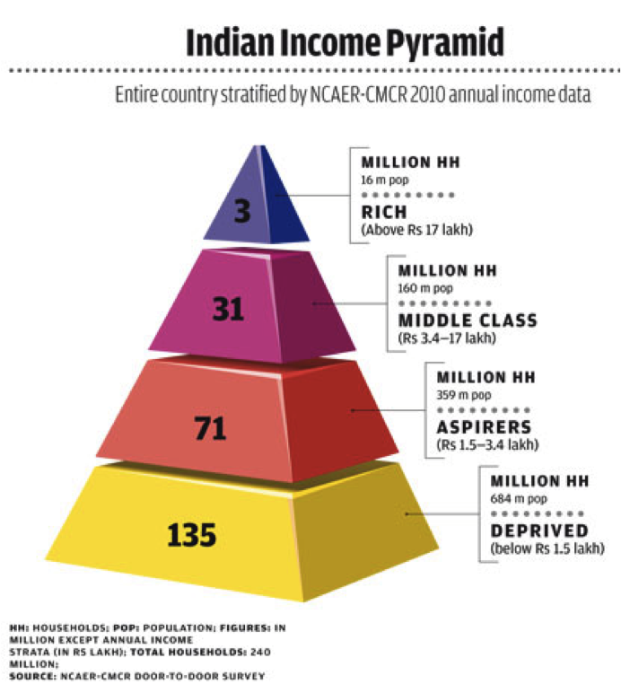

1. Neighbour countries(Stage 2): Pakistan, Nepal, Sri Lanka, Myanmar.
2. International Export(Stage3): UAE , England, Europe , North America etc.

Research and information gathering.

[This page will have the research and data of how many households are middle class in India, how big is the market for handy craft, problems faced while buying the handcraft by people]

[this will also have the ways in which we will research such as by:

1. Survey the local population of the area:
2. in the markets(delhi Jaipur hydrabad).
3. Poor areas
4. Areas away from the market (like in chattisgarh ) which is isolated from areas like rajasthan or delhi where there is a huge market for these.]
5. Opinion polls
6. Reviews of online markets like amazon or Flipkart or Paytm or Snapdeal to see the demand of these items and problems with these online giants.

[Add an image to complete these and 2- 3 more points on how we can research]

Price/Pricing of product

1. Initially sell at cost price and including all the marketing expense(slight loss)
2. Check Competitors price then price accordingly

[Add more points]

:P don’t have time

Promotion

Channels to advertise:

How to market/promote:

1. Bill Boards of large size in prominent places across Delhi first.
2. Local Radio broadcasts
3. Add in Newspapers
4. Digital Marketing through Google Ad Sense, YouTube ads etc
5. Social Media marketing through facebook, instagram, twitter etc.
6. Local Marketing Agents (who distribute the fliers)
7. Offering heavy discounts for fixed period of time
8. Ads in malls and stalls all over markets in Delhi.

[Add image, increase line spacing font size etc]

[add a few more points ] [our project will be of 13-14 pages]

Brand Name, Range of Products, Tag Lines

Labelling and Packaging

3 points:

Why is it important?

How to Label?

Through packaging.

Difference between labelling and packaging?

<content>

Warehousing and Transportation

3 points

Why is Warehousing and Transportation so important part of marketing?

<content>

Benefits of proper Warehousing and transportation?

<content>

Types and ways of transportation

<content>

Consumer Protection Rights

(I don’t have a clue)

What we learned through this project?

Bibliography